

**INSTALLATION MANUAL**

### Table of Contents

### Applicable Version………………..….……………………………….……………………….………1

### Installation....………………………….……….………………………………………………………….1

### Configuring Ingenico……………………………………………………………………………………6

### Applicable versions

|  |  |
| --- | --- |
| **Applications** | **Versions** |
| PHP | 5.3.x to 5.6.x |
| Magento | 1.7.x to 1.9.x |

**Installation**

Please follow the given steps to install and run the Ingenico Payment Gateway module

1. First, you need to log in to the Magento administrator area.
   1. Visit URL www.<mysite.com>/admin.
   2. Enter Username and password.
2. Then go to **System -> Magento Connect -> Magento Connect Manager**. 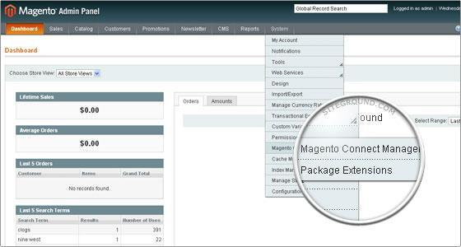
3. A new page will open for the Magento Connect Manager and you will be asked to provide your administrative credentials again.

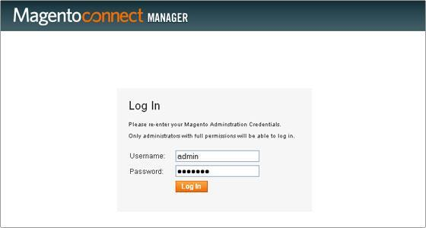

1. Once logged in you will see 2 sections: **Extensions** and **Settings**. It is recommended to verify the options chosen in the Settings section first.

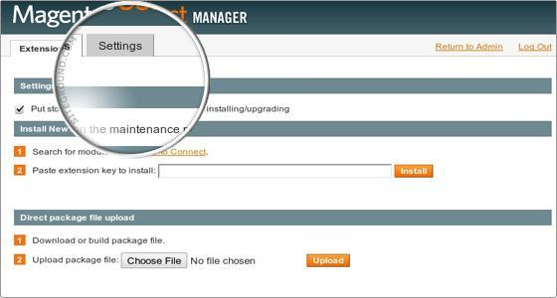

1. In the Settings section you can configure options if you need to do. It is safe to leave those options to their default values.

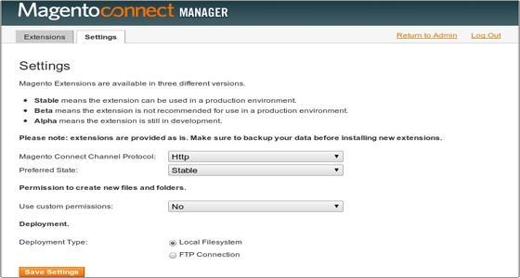

1. Go to **Extensions.** In the “*Direct package file upload”* tab click on “*Browse*” button to upload the package file. Select Ingenico.tgz file provided by Ingenico payment gateway module and click *open*. Now click “*upload*” to start uploading files.
2. Wait until you get a message as “Package Installed”. The Console Box displays the results of your install. If there are any issues, it will be displayed in this box. After the extension is properly installed a screen for a successful installation will appear:

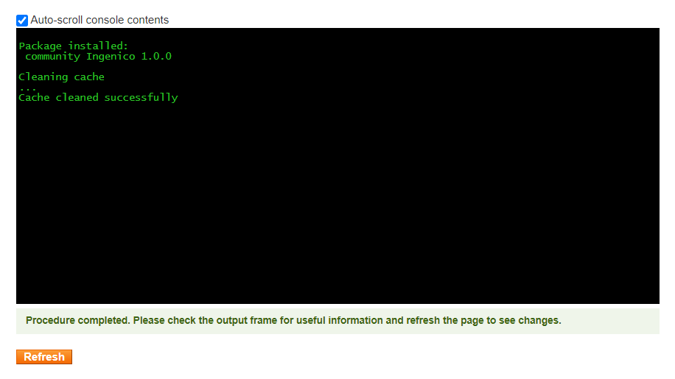

1. Click refresh. Once the extension is installed it is important to go back to Magento admin (Click on Return to admin).
2. Ingenico is now installed on your site.

**Upgrade**

1. To upgrade the module we have to uninstall the previously installed module. So we have to navigate to the Magento connect manager as per the previous steps and then find the “Ingenico” module from the list. Select Uninstall the from the dropdown and Click on “Commit Changes”  
   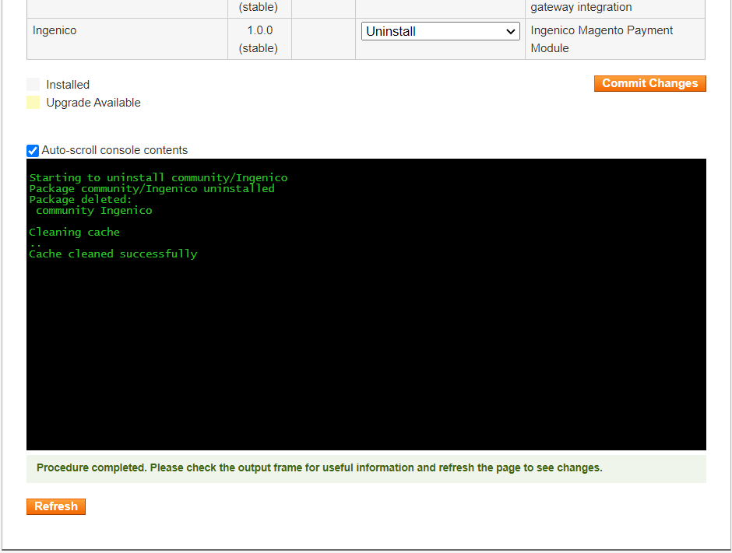
2. Once the uninstall is successful, you can install the extension again as shown in the installation steps above.

**Configuring Ingenico**

1. Go-to admin panel.
2. Go-to menu System->Configuration.
3. Select “Payment methods” under the “Sales” tab on the left panel.
4. Now you should be able to see the Ingenico Payment Gateway. Click on configure.
5. Configure it as below:

|  |  |
| --- | --- |
| **Column Name** | **Description** |
| Enabled | “Yes” to enable and use, else “No” to disable ingenico |
| Title | Title Text to display during checkout process |
| Salt | Enter Salt. |
| Merchant Code | Enter merchant code. |

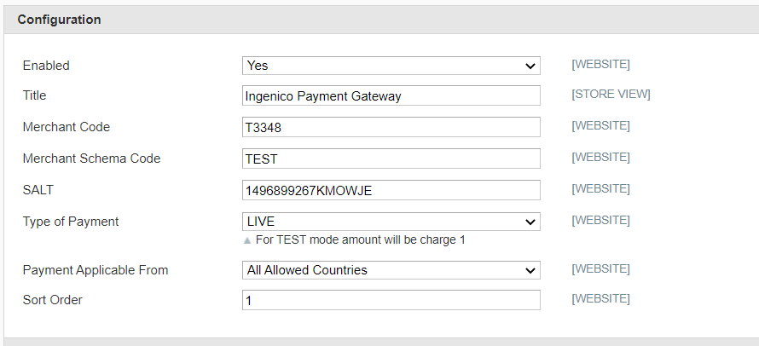

1. Now click on “Save Config” on top- right corner.
2. Ingenico Payment Gateway is now configured & ready to use.

**Advanced Configuration**

There are also some advanced configuration options you may consider as shown below:

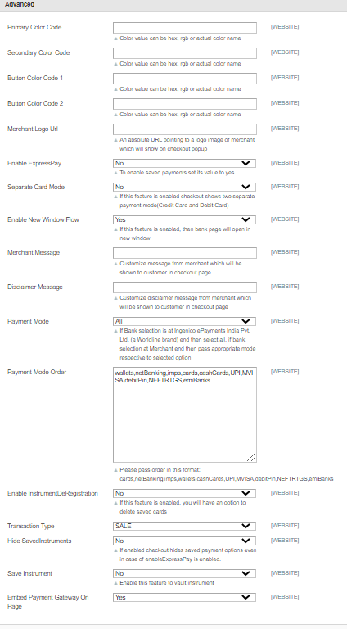

## Features List

### Dual verification of response:

We are validating responses with a hash value and call again Payment Gateway for dual verification from the payment gateway before updating to the order status.

### Reconciliation

Merchants can update the pending status of the order automatically if the payments are successful. This page can be found under Ingenico > Reconciliation

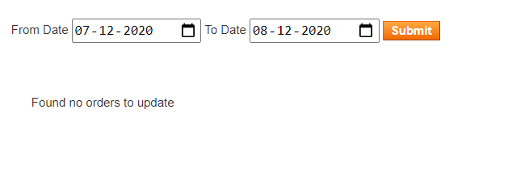

### Logs request and response

Daily new file creates for the logs request and response from the server for future reference.

### S2S Verification

If we do not receive any response from the payment gateway then after 30 mins, we will get a response from the server and based on the response it will update order status.

To configure S2S URL, contact prod team.

**S2S url format** : [http://DOMAIN_NAME/index.php/ingenico/payment/s2sverification](http://domain_name/index.php/ingenico/payment/s2sverification) or [https://DOMAIN_NAME/index.php/ingenico/payment/s2sverification](http://domain_name/index.php/ingenico/payment/s2sverification)

**S2S url example** : [http://example.com/index.php/ingenico/payment/s2sverification](http://localhost/magento_mirror/index.php/ingenico/payment/s2sverification)

### MCG

It supports the multi currency like USD, GBP, SGD and a lot more.

### 

### Payment Verification

Merchants can verify the status of their payment by using the Payment Verification page. The payment verification page can be found under Ingenico > Payment Verification

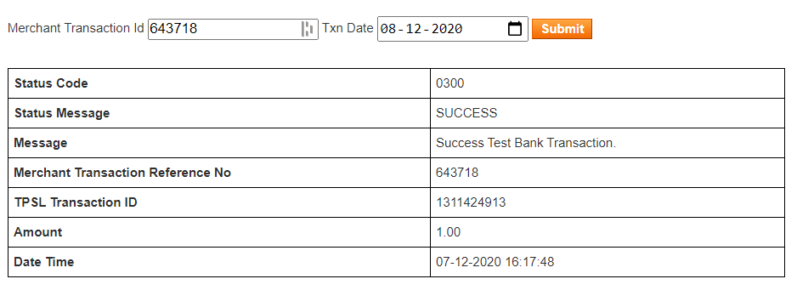

### Refund

Merchants should be able to process the refund online for the order whose payment has been done via Ingenico.

To refund a order, create a new Credit Memo and click on the Refund button as shown below

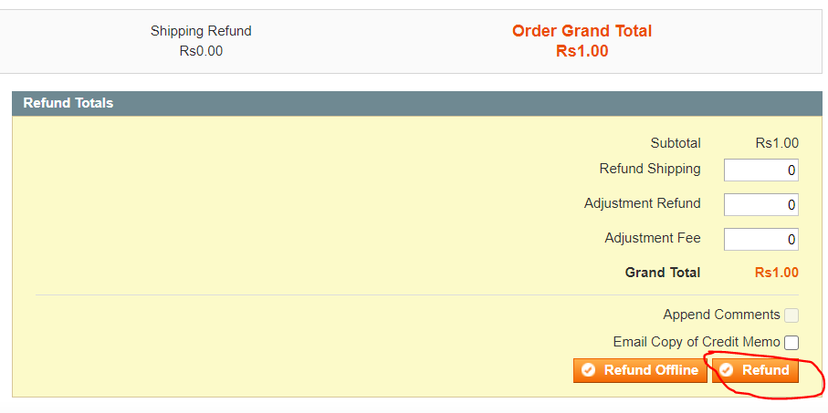

### Embed Payment Gateway

After enabling this setting, payment gateway displays like embedded on the page instead of pop-up so user experience would be good.

## Documentation link

[**https://www.tecprocesssolution.com/proto/p2m/client/salt-based-documentation.htm#online**](https://www.tecprocesssolution.com/proto/p2m/client/salt-based-documentation.htm#online)